SHOPPING MANAGEMENT SYSTEM

Project Report Submitted in Partial fulfillment of the requirement for the award of

BACHELOR OF SCIENCE INFORMATION TECHNOLOGY (B.Sc. IT)

Submitted by,

Alamdar Abbas

Reg No:1408020993

Under the guidance of

MR. ARANYA PRAKASH SRIVASTAVA

SIKKIM MANIPAL UNIVERSITY (SMU) - DIRECTORATE OF DISTANCE EDUCATION

January 2016

DECLARATION

I (Alamdar Abbas) (1408020993) hereby declare that the project report entitled:

A Project Report on “RECRUETMENT, SELECTION & RETANTION PRACTICES in CETPA INFOTECH PVT. LTD. Ltd.” submitted in partial fulfillment of the requirement for the degree of Bachelor of Science Information Technology to Sikkim – Manipal University, India, is my original work and not submitted for the award of any other degree, diploma, fellowship, or any other similar title or prizes.

Place: Noida
Date: 24-01-2016
(Alamdar Abbas)
Registration No.: 1408020993

CERTIFICATE BY THE GUIDE

Certified that this project report titled is the bonafide work of “RECRUETMENT, SELECTION & RETANTION PRACTICES in Cetpa Infotech Pvt. Ltd.” “ Alamdar Abbas” bearing Reg. No 1408020933 who carried out the project work under my guidance.

Signature
FACULTY IN CHARGE
Designation:

CERTIFICATE

The project report of Alamdar Abbas (Registration No.1408020993) A Project Report on “RECRUETMENT, SELECTION & RETANTION PRACTICES in Cetpa Infotech Pvt. Ltd.” is approved and is acceptable in quality and form.

Mr. Anurag
Internal Examiner External Examiners
(Mr. Anurag)

INTRODUCTION

SYNOPSIS

The Project entitled "e-Shopping" is a web-based application Software developed in PHP LANGUAGE using PHP as front end on Pentium machine. The main aim of "e- Shopping" is to improve the services of Customers and vendors. It maintains the details of customer payments, product receipts, addition of new customers, products and also updating, deletion for the same. It also stores the details of invoices generated by customer and payments made by them with all Payments details like credit card. The primary features of the project entitled "ONLINE SHOPPING" are high accuracy, design flexibility and easy availability. And also it uses database tables Representing entities and relationships between entities.

OVERVIEW OF ONLINE SHOPPING

The central concept of the application is to allow the customer to shop virtually using the Internet and allow customers to buy the items and articles of their desire from the store. The information pertaining to the products are stores on an RDBMS at the server side (store). The Server process the customers and the items are shipped to the address submitted by them. The application was designed into two modules first Os for the customers who wish to buy the articles.Second is for the storekeepers who maintains and updates the information pertaining to the articles and those of the customers? The end user of this product is a departmental store where the application is hosted on the web and the administrator maintains the database. The application which is deployed at the customer database, the details of the items are brought forward from the database for the customer view based on the selection through the menu and the database of all the products are updated at the end of each transaction. Data entry into the application can be done through various screens designed for various levels of users. Once the authorized personnel feed the relevant data into the system, several reports could be generated as per the security.
e-Shopping

Online shopping is a form of electronic commerce where the buyer is directly online to the seller's computer usually via the internet. There is no intermediary service. The sale and purchase transaction is completed electronically and interactively in real-time such as Amazon.com for new books. If an intermediary is present, then the sale and purchase transaction is called electronic commerce such as eBay.com.
Proposed System:

The development of this new system contains the following activities, which try to develop on-line application by keeping the entire process in the view of database integration approach.
- Secure registration and profile management facilities for Customers.
- Browsing through the e-Mall to see the items that are there in each category of products like Apparel, Kitchen accessories, Bath accessories, Food items etc.
- Creating a Shopping cart so that customer can Shoppe ‘n’ no. of items and checkout finally with the entire shopping cart
- Customers should be able to mail the Shop about the items they would like to see in the Shop
- Secured mechanism for checking out from the Shop( Credit card verification mechanism )
- Updates to customers about the Recent Items in the Shop.
- Uploading ‘Most Purchased’ Items in each category of products in the Shop like Apparel, Kitchen accessories, Bath accessories, Food items etc.
Number of Modules
The system after careful analysis has been identified to be presented with the following modules:
- Customer.
- Admin Module.
- Security and Authentication
Software Requirements
Operating System : Windows XP/7/8/8.1 or Linux
User Interface : HTML, CSS
Server-side Scripting : PHP Script
Client-side-Scripting : Java Script
Programming Language : PHP
Web Applications : Wamp Server
IDE/Workbench : Net Beans
Database : MySQL
Server Deployment : Apache

Hardware Requirements
Processor : Pentium IV
Hard Disk : 40GB
RAM : 512MB or more

System Analysis
&
Design

Introduction
Analysis is the focus of system developing and is the stage when system designers have to work at two levels of definition regarding the study of situational issues and possible solutions in terms of “what to do” and “how to do”.
System Study
DEFINITION OF THE SYSTEM
A system is an orderly grouping of independent components linked together according to a plan to achieve a specific objective. Its main characteristics are organization, interaction, independent, integration and central objective a system does not necessarily mean to a computer system. It may be a manual system or any other names.
NEEDS OF THE SYSTEM
Social and economic factor: a wave of social and economic changes often follows in the wake of the new technology. New opportunities may arise to improve on a production process or to do something that was not previously possible. Changes in the ways individuals are organized into groups may then be necessary, and the new groups may complete for economic resources with established units.
Technological factor: people have never before in a time when the scope of scientific inquiry was so broad, so when the speed of applying the new technology accounts for many changes in the organization.
High level decisions and operating processes: in response to technological, socio-economical factors, top level managers may decide to recognize operations and introduce new products. To deal with these needs, people commonly seek new modified information to support the decision. When that happens, then they obtain turn to a computer system for help the information users and data processing specialist then work together to complete a series of steps in a system study to produce output results to satisfy information needs.
System analysis
System Analysis is a process by which we attribute process or goals to a human activity, determine how well those purpose are being achieved and specify the requirements of the various tools and techniques that are to be used within the system if the system performances are to be achieved.
SYSTEM PLANNING
Planning for information systems has a time horizon and a focus dimension. The time horizon dimension specifies the time range of the plan, where as the focus dimension relates whether the primary concern is strategic, managerial, or operational. The system i.e. The Project that we were assigned was required to complete within 20 weeks. What we had planned is as follows:
Requirements analysis, Preliminary Investigation & Information Gathering should be covered within the 1st and 2nd week. Since I was not aware of MYECLIPSE IDE it require 1 week for me to adjust with that tool. 12 Weeks for the design of the system under development. 1 week for Testing & Implementation. And rest 2 reserve weeks.

PRELIMINARY INVESTIGATION
The initial investigation has the objective of determining the validity of the user’s request for a candidate system and whether a feasibility study should be conducted.
The objectives of the problem posed by the user must be understood within the framework of the organization’s MIS plan. Ihad investigated from the concerned authority about the project
INFORMATION GATHERING
Akey part of feasibility analysis is gathering information about the present system. The analyst must know what information to gather, where to find it, how to collect it, and what to make of it. The proper use of tools for gathering information is the key to successful analysis. The tools are the traditional interview, questionnaires, and on-site observation.
STRUCTURED ANALYSIS
The traditional tools of data gathering have limitations. An English narrative description is often vague and difficult for the user to grasp. System flowcharts focus more on physical than on logical implementation of the candidate system. Because of these drawbacks, structured tools were introduced for analysis. Structured analysis is a set of techniques and graphical tools (DFD) that allow the analyst to develop a new kind of system specifications that are easily understandable to the user.
CONTEXT LEVEL DATA FLOW DIAGRAM

SELLER
Online
shopping
BUYER

Database Tables

- Admin
- Product
- Orders
- Customers
- News
- Complaint
- Sami

Data flow Diagram

- A data flow diagram (DFD) is a graphical representation of the "flow" of data through an information system.

Home Page
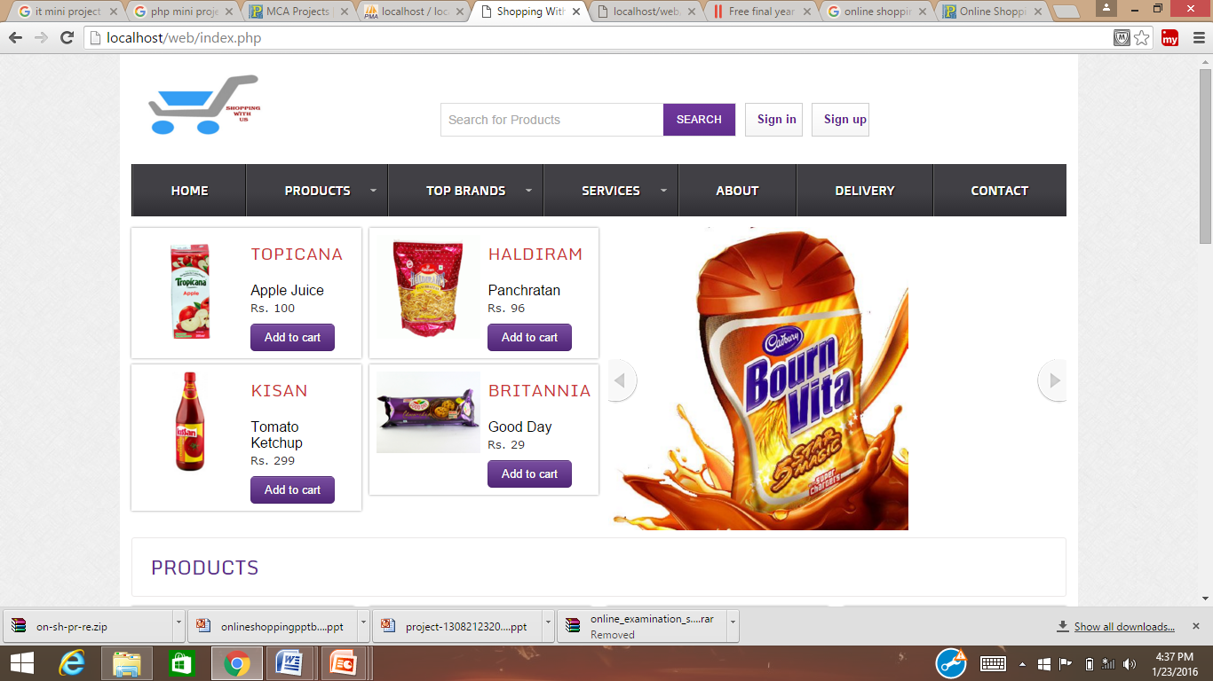

Products
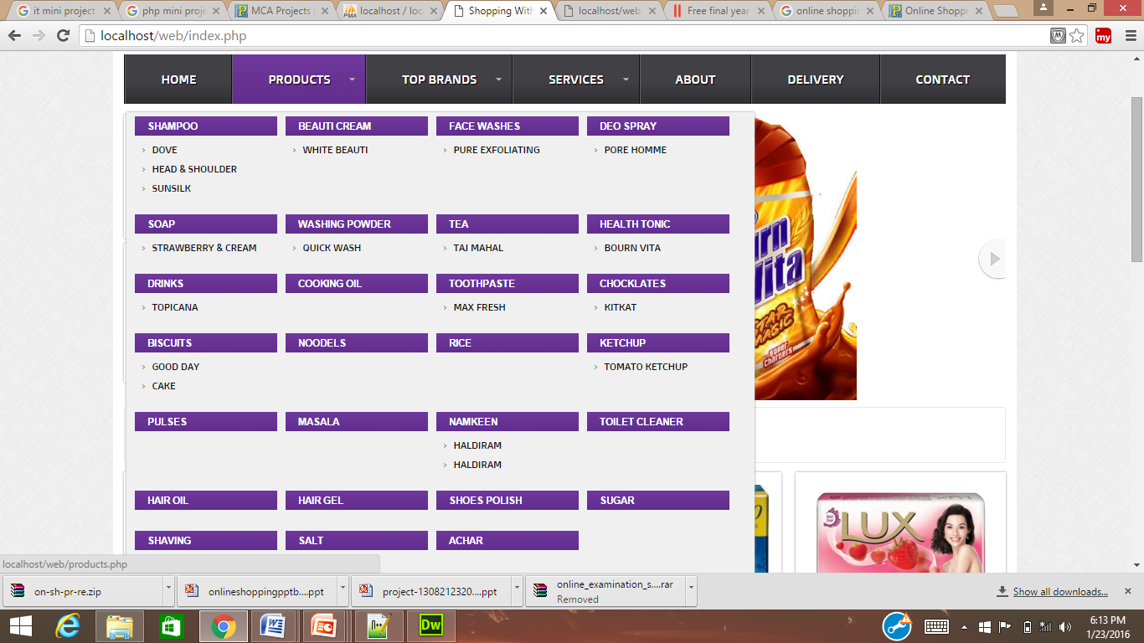

Contact
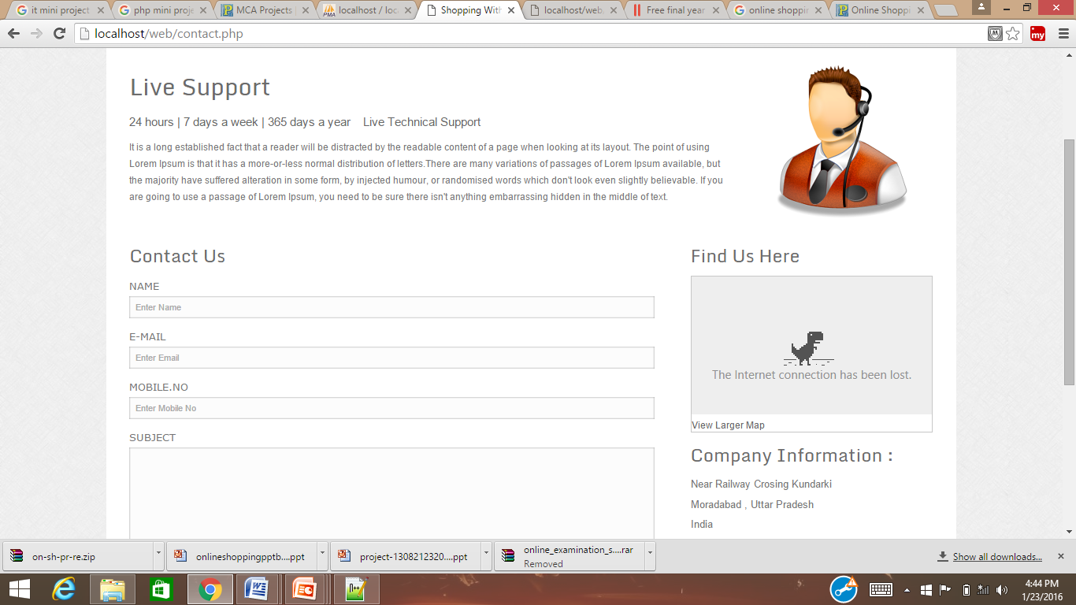

User’s Account
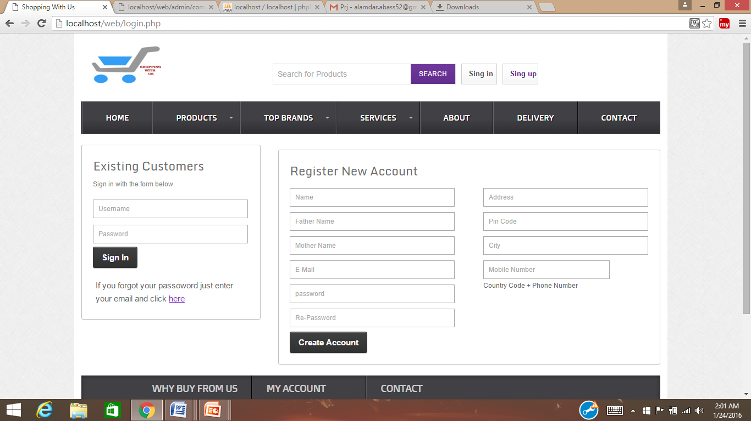

Preview
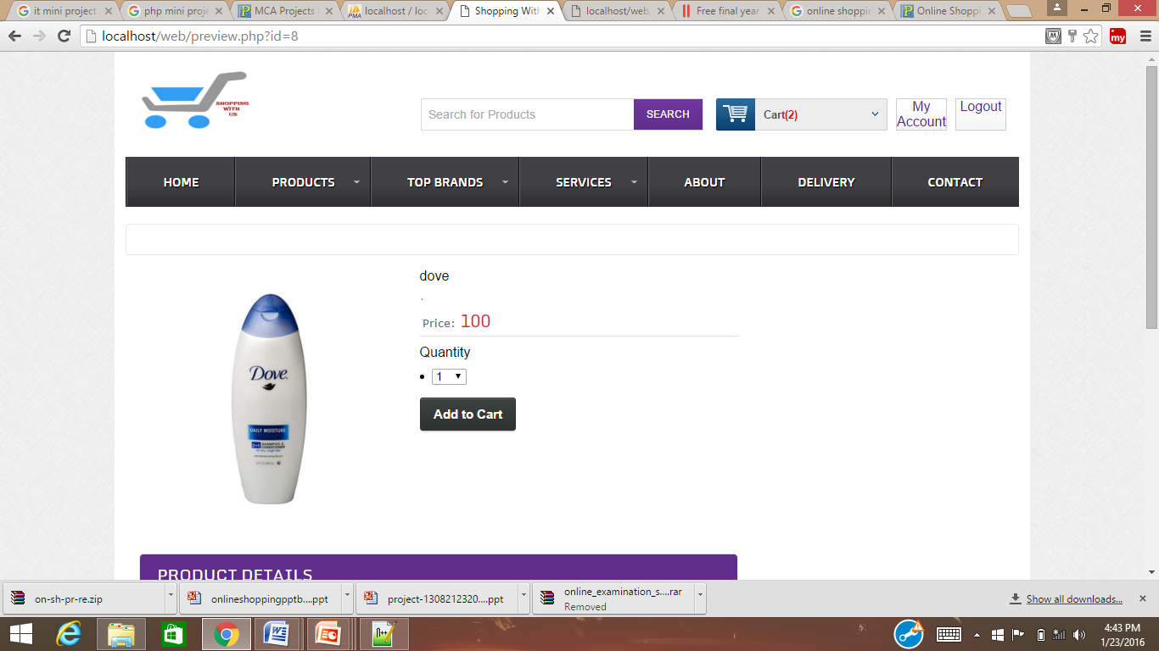

Cart
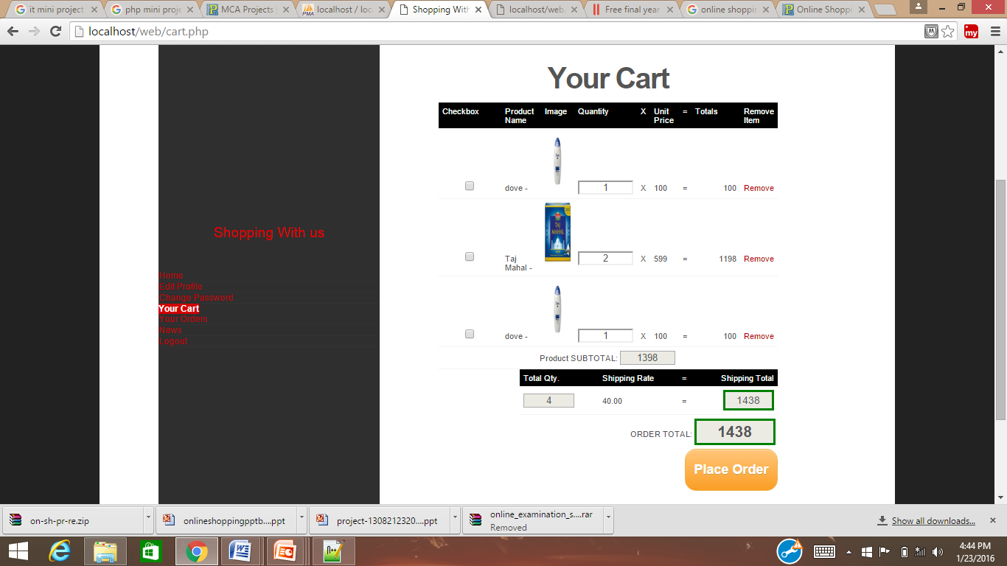

Orders
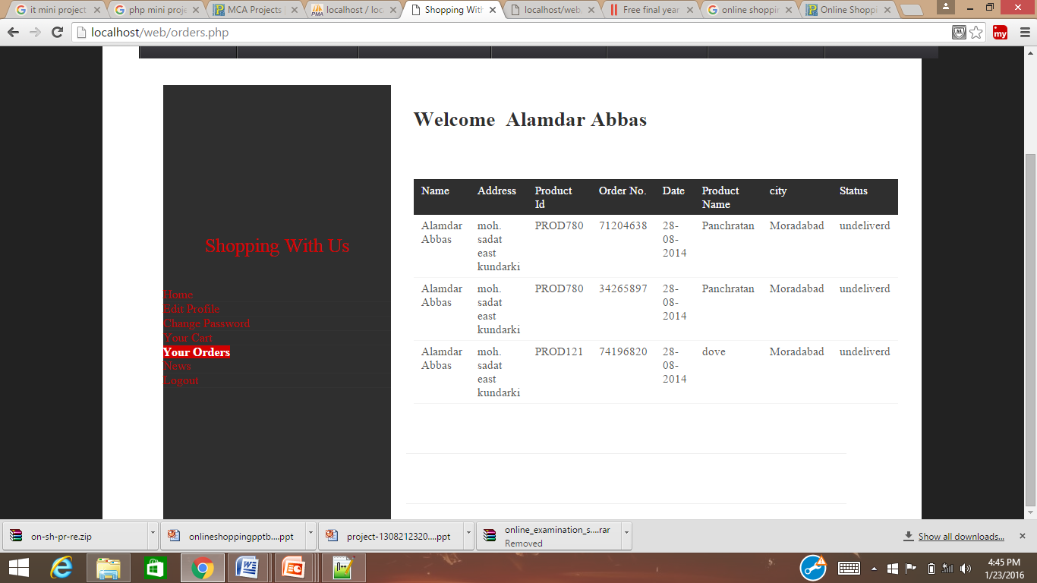

Member’s Home
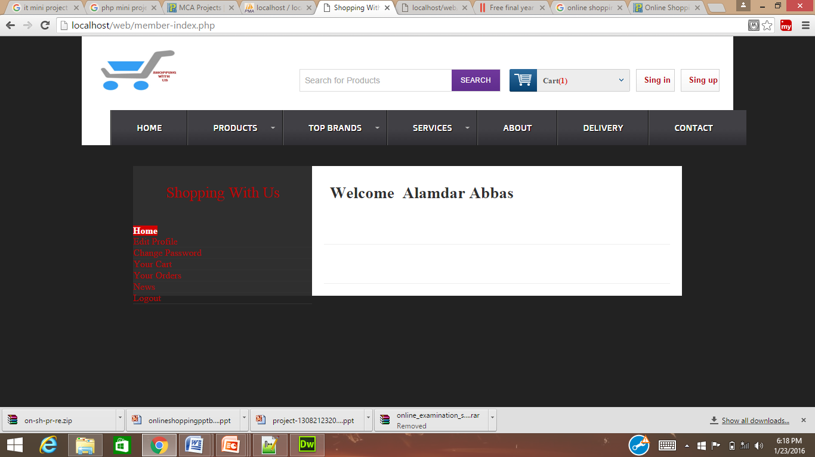

Edit Profile
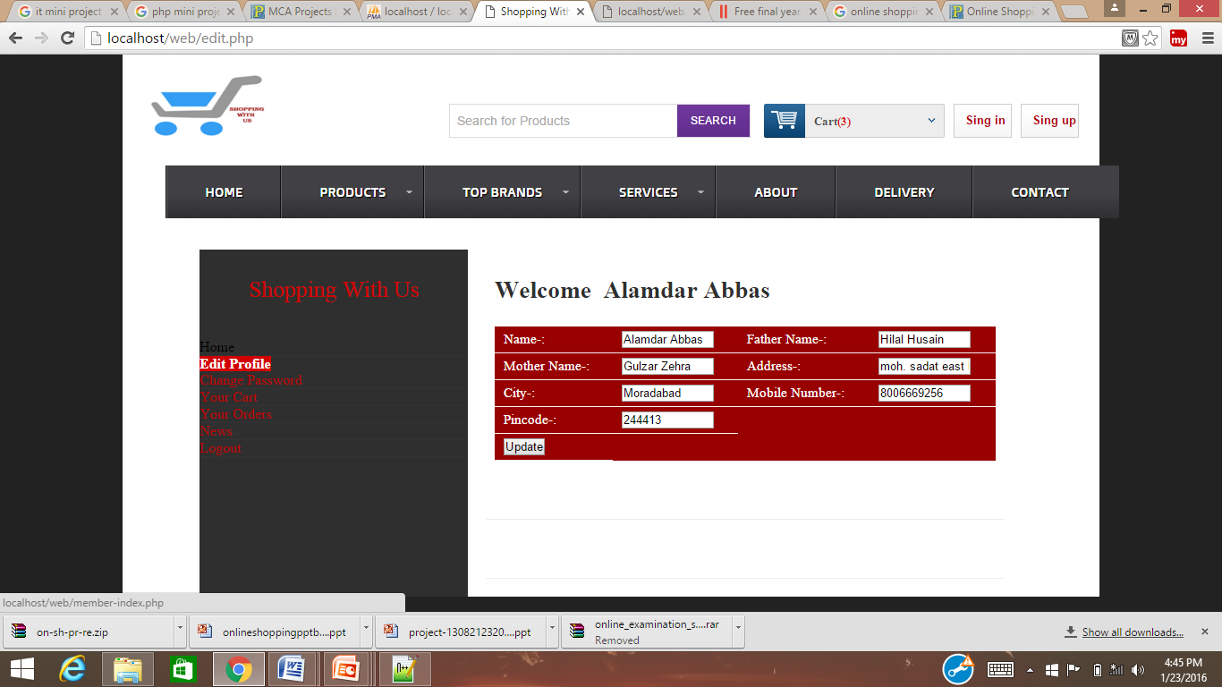

Change Password
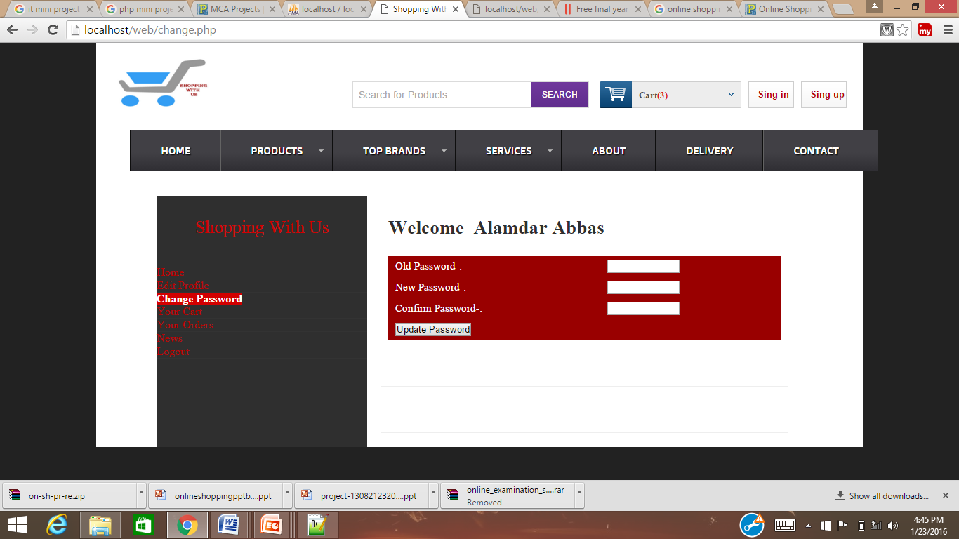

News
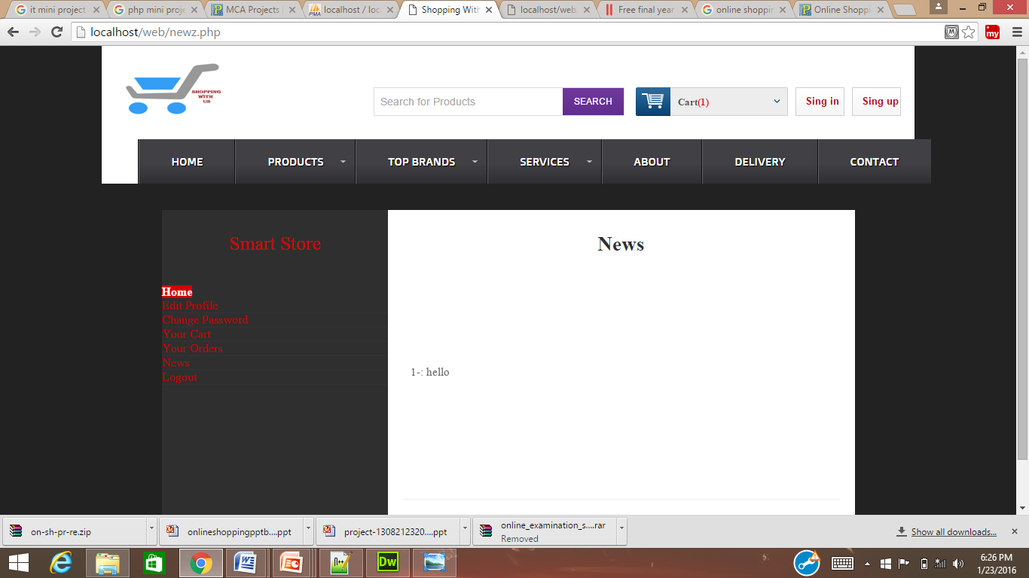

Admin’s Home

Add Product
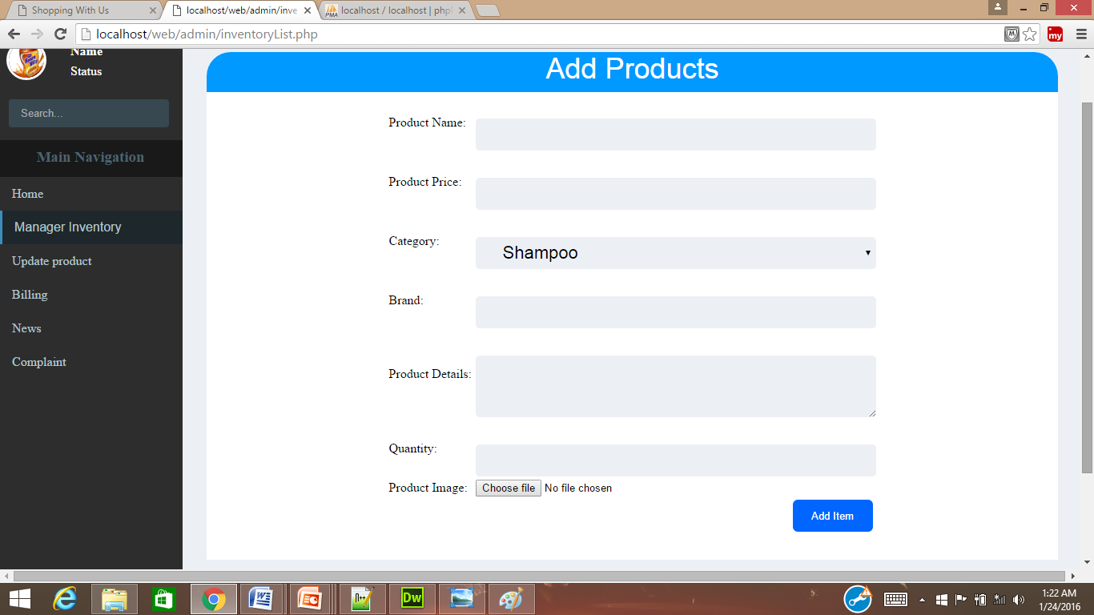

Update Product
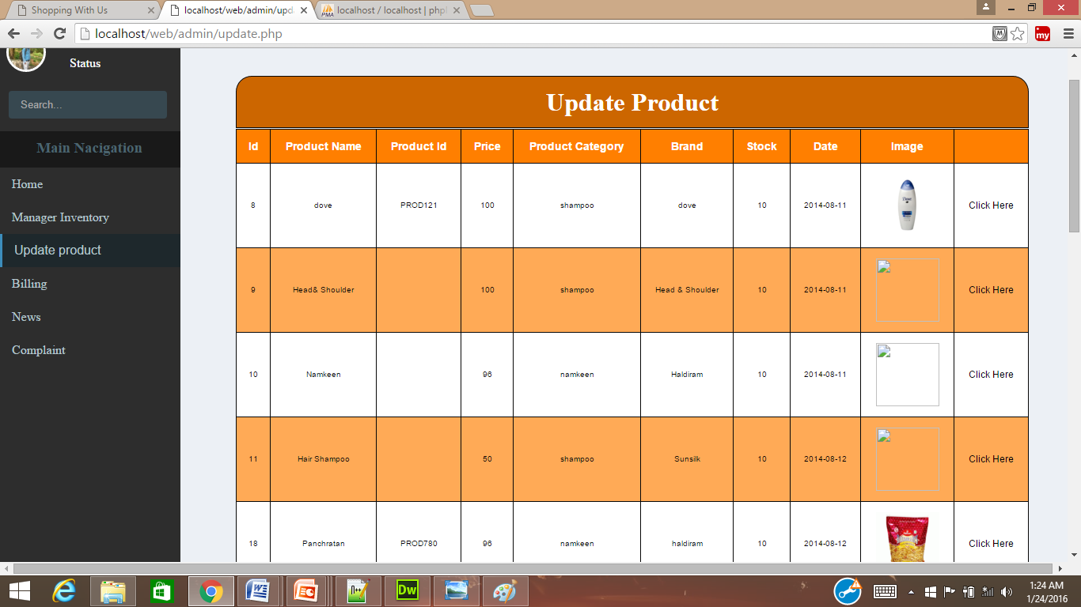

Billing
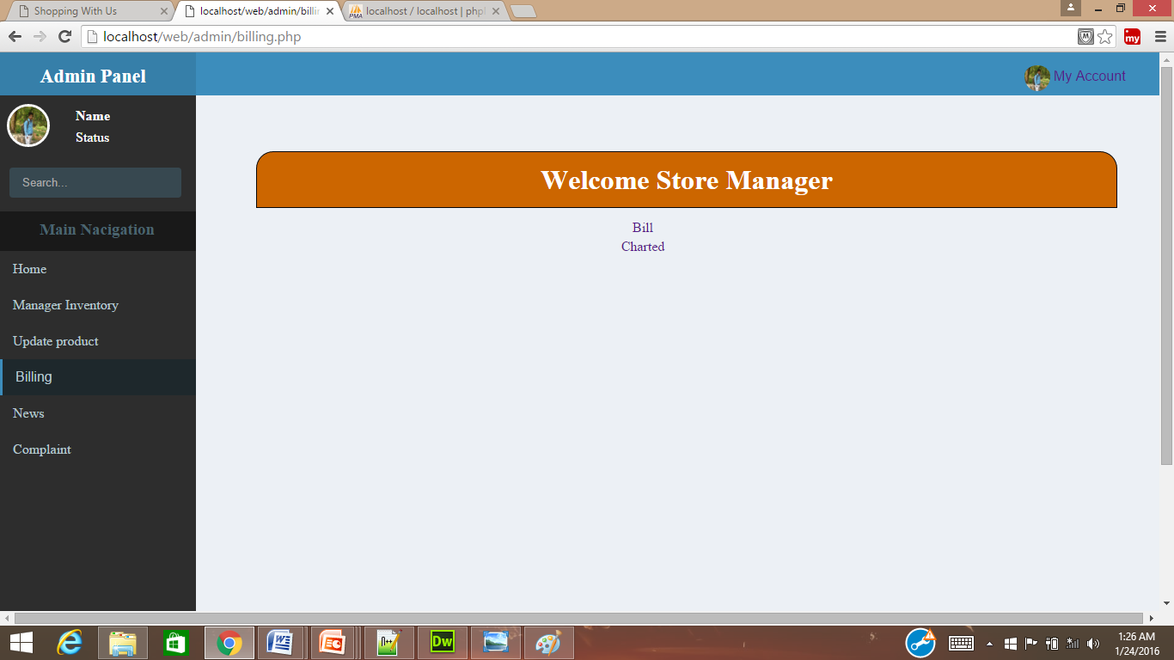

Bills
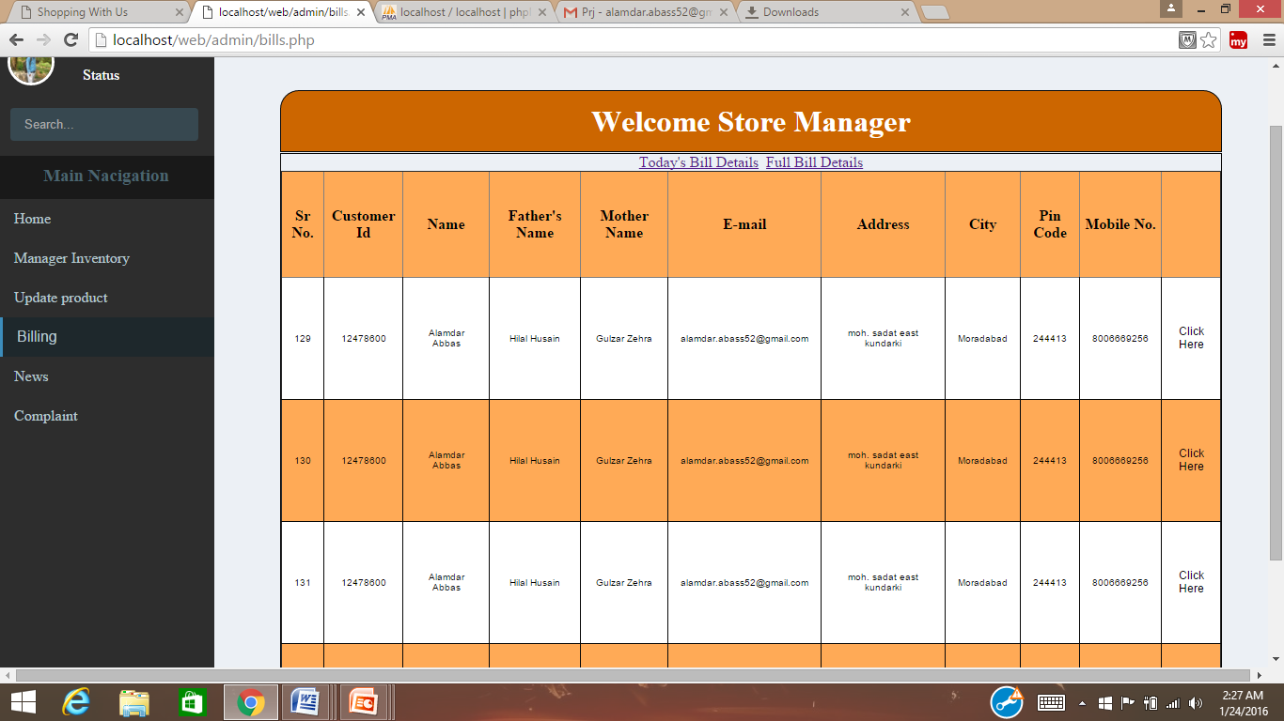

Charted
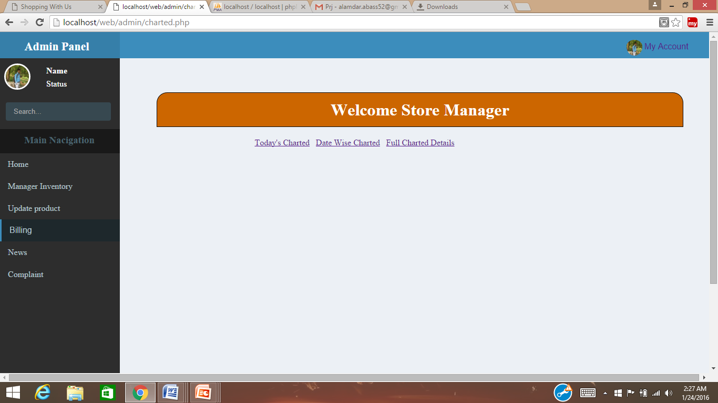

News
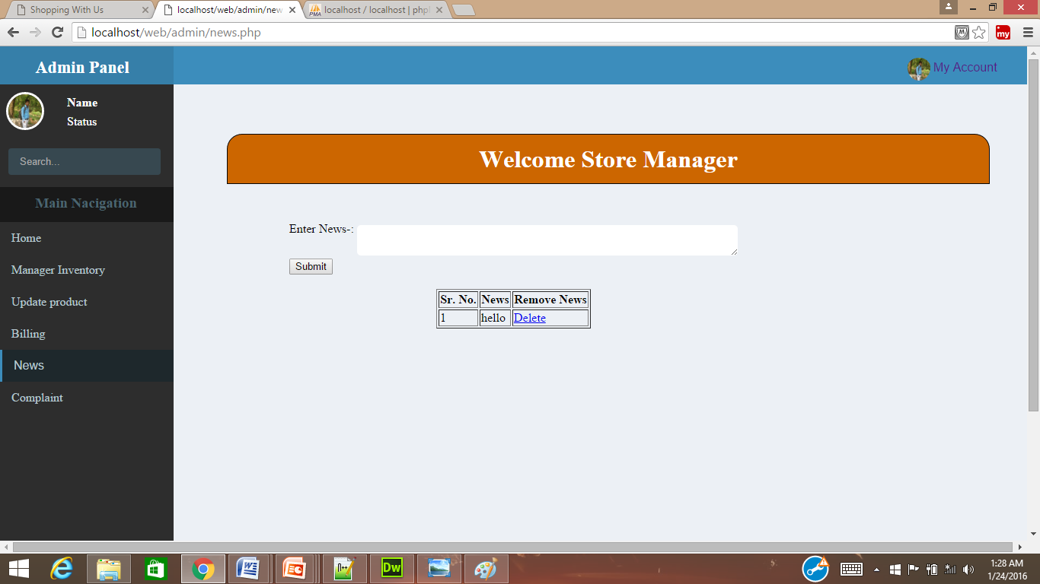

Complaint
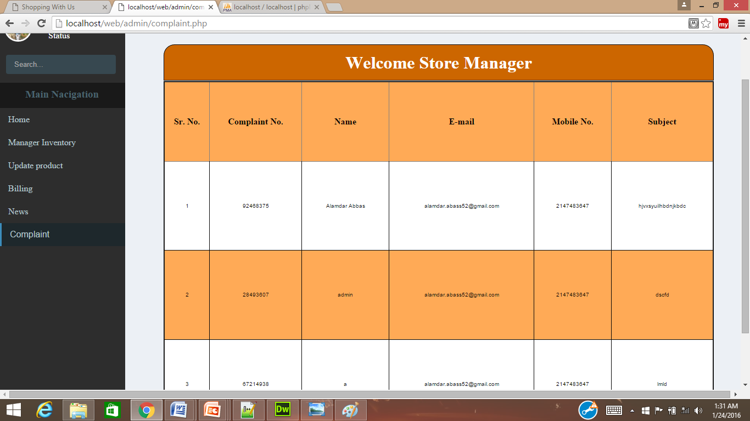

INTERPRETATION OF
THE RESULT

The system has been implemented and tested successfully. It meets the information requirements specified to the great extent. although the system has been designed keeping the present and future requirements in mind and made very flexible.
There are limitations of the system. proper consideration has been given for a wide range of new enhancements.The system is developed user friendly.In future , if it is required to generate reports other than provided by the system it can be simply achieved by a separate module to the main menu without affecting the design of the system.

ADVANTAGES

(1)it simplifies the operation.
(2)it avoids a lot of manual work.
(3)every transaction is obtained and processed immediately.
(4)avoids errors by avoiding the manual work.
(5)user friendly screen to enter the data and enquire the database tables.
(6)online help messages available to the operating system.
(7)user can easily access the system without much experience.
(8)provide hardware and software securities.
(9)portable and flexible for further extensions.

Conclusion

The central concept of the application is to allow the customer to shop virtually using the Internet and allow customers to buy the items and articles of their desire from the store.
The information pertaining to the products are stores on an RDBMS at the server side (store).The Server process the customers and the items are shipped to the address submitted by them.
The application was designed into two modules first Os for the customers who wish to buy the articles. Second is for the storekeepers who maintains and updates the information pertaining to the articles and those of the customers.
The end user of this product is a departmental store where the application is hosted on the web and the administrator maintains the database. The application which is deployed at the customer database, the details of the items are brought forward from the database for the customer view based on the selection through the menu and the database of all the products are updated at the end of each transaction.

Thank You

